|  |  |
| --- | --- |
|  | **Year 11 ATAR Human Biology**  **Task 2 – Cells, metabolism and enzymes** |

|  |  |  |  |
| --- | --- | --- | --- |
| **Name:** | **Teacher: ANSWERS** | **Date:** | **Score: /55** |

**Assessment type:** Test

**Conditions**

Time for the task: 55 minutes

**Task weighting** - 5%

Total 55 marks

**Section 1: Multiple-choice (10 marks)**

This section has 10 questions. Answer all questions by writing the letter corresponding to the correct answer in the box provided.

1. Homeostasis is
2. when all cells are kept the same.
3. when the muscle cells work to keep the cellular environment constant.

**C**

1. **when body systems work together to maintain a constant cellular environment.**
2. when the respiratory system works to keep the circulatory system cellular environment the same.
3. Osmosis is the movement of:
4. water (solvent) molecules into a cell.
5. solute molecules into a cell.
6. water (solvent) molecules from a concentrated solution to a dilute solution.
7. **water (solvent) molecules from a dilute solution to a concentrated solution.**
8. What method of transporting materials in or out of a cell is represented by the diagram shown below?

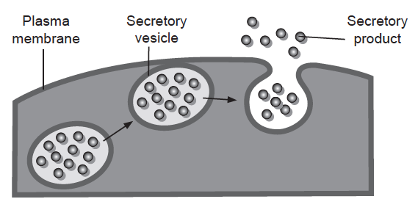

1. endocytosis

**D**

1. facilitated diffusion
2. active transport
3. **exocytosis**
4. Which of the following substances could pass directly through the bi-lipid layer of the cell

membrane?

1. **Alcohol**

**A**

1. Salt
2. Glucose
3. Bacteria
4. The first phase in the breakdown of glucose is called
5. **glycolysis.**

**A**

1. the Krebs cycle.
2. the citric acid cycle
3. the electron transport system.

Use the following information to answer questions 11 and 12. The diagram below represents a “lock and key” model for the chemical reaction in which the enzyme lipase breaks down fats in to fatty acids and glycerol.

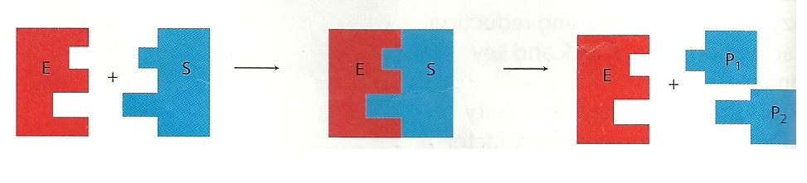

I II III IV V

Vi

1. The enzyme-substrate complex is represented by
2. I and II
3. **III**

**B**

1. V and Vi only
2. IV, V and Vi
3. The products of this reaction are represented by
4. I and II
5. III

**C**

1. **V and Vi only**
2. IV, V and Vi
3. Cells are small in size in order to create a
4. large amount of cytoplasm for cellular reactions.
5. small amount of cytoplasm for cellular reactions.

**C**

1. **large surface area to volume ratio.**
2. small surface area to volume ration.
3. Which of the following statements concerning enzyme action is correct?
4. **Enzymes work within a narrow set of temperature and pH conditions.**

**A**

1. Enzymes act to increase the activation energy needed for a reaction to proceed.
2. A specific enzyme can act on a wide variety of substances
3. Some enzymes act to slow down chemical reactions.
4. The formation of ATP during aerobic respiration is best represented by
5. **glucose+ oxygen → carbon dioxide+water + 38ATP**

**A**

1. glucose+ oxygen → carbon dioxide+water + 2ATP
2. glucose+ carbon dioxide → carbon dioxide+water + 2ATP +lactic acid
3. glucose+ oxygen → carbon dioxide+water + 26ATP

**End of Section 1 – See below for Section 2**

**Section 2: Short answer (31 marks)**

This section has four questions. Answer all questions. Write your answers in the spaces provided.

**Question 11 (7 marks)**

Parts (a) and (b) of this question refer to the diagram below which shows a generalised cell.

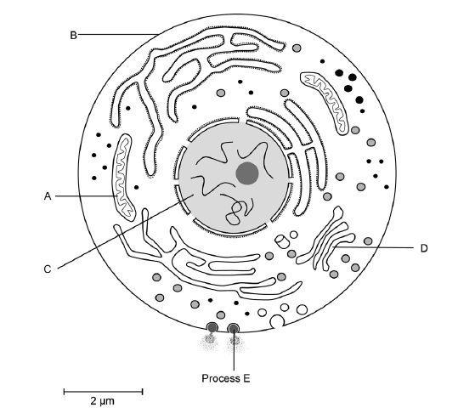

1. Complete the following table.

|  |  |  |
| --- | --- | --- |
| **Organelle** | **Name** | **Function** |
| **A** | **Mitochondria** | * **Produces energy** * **Site of respiration** * **Contains mDNA** |
| **B** | **Cell Membrane** | * **Controls entry** * **Exit of materials** * **Receptors** * **Cell recognition** * **Separates** |
| **D** | **Golgi body** | * **Package material for export** * **secretion** |

(1 Mark for each correct name and 1 mark for 1 correct function stated for each organelle) (6 marks)

1. Process E as labelled on the diagram shows the movement of a substance out of the cell via a vesicle. What name is given to this process?

_____ **Exocytosis** ________________________________________________________________

(1 mark)

**Question 12 (13 marks)**

Complete cellular respiration is an enzyme controlled chemical reaction that provides cells with energy.

1. Identify the role of ATP on cell metabolism.

_____ **stores energy / releases energy / provides energy** _______________________________

(any 1 from above) (1 mark)

1. Complete the chemical equation below, which represents the breakdown of ATP.

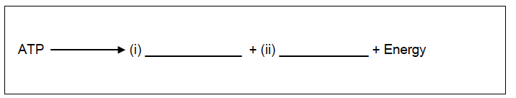

**P**

**ADP**

(word equation is ok/award the mark) (2 marks)

1. List two cellular uses for energy.

One: ___________________________________________________________________________

Two: ___________________________________________________________________________

(2 marks)

**Any 2 from the following:**

* **Movement**
* **Division / /growth / repair**
* **Active transport**
* **Synthesis**
* **Exocytosis / endocytosis / vesicular transport**
* **Maintaining cell organisation**

The diagram below shows the mitochondrion of a skin cell and of a muscle cell.

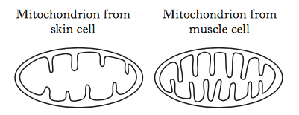

1. Explain the benefit of the mitochondrion of the muscle cell having a folded inner membrane.

___________**Increase surface area (1)**

**Therefore increase in the amount of ATP produced (1)**_________________________________

(2 marks)

The following diagram shows the steps involved in the partial breakdown of glucose in muscle cells.

Process A Process B

glucose 🡪 substance X 🡪 lactic acid

1. Name process A

___________**Glycolysis**__________________________________________________________

(1 mark)

1. What name is given to substance X?

__________**Pyruvic acid/ pyruvate**_________________________________________________

(1 mark)

1. Using examples, describe the difference between a catabolic reaction and anabolic reaction.

|  |  |  |
| --- | --- | --- |
|  | **Catabolic reaction** | **Anabolic reaction** |
| **Description** | **Breakdown large molecules to smaller molecules (1)** | **Synthesise large molecules from small molecules (1)** |
| **Example** | **Any 1 from for 1 mark:**   * **Respiration**   **• Digestion** | **Any 1 from for 1 mark:**   * **Protein production**   **• Hormone production** |

(4 marks)

**Question 13 (4 marks)**

The table below states the types of different tissue found in the body.

Complete the table by filling in the information on the function of each type of tissue and provide an example of where it can be found in the body.

|  |  |  |
| --- | --- | --- |
| **Type of tissue** | **Function** | **Location in Human Body** |
| **Connective** | **Provides support for the body and helps hold body parts together** | **Bone/cartilage/tendons/**  **Ligaments and fat storage tissue/blood** |
| **Muscular** | **Respond to stimulus by contracting** | **Cardiac – heart**  **Skeletal – muscles**  **Involuntary – stomach/intestines/iris/blood vessels/uterus etc** |
| **Epithelial** | **Cover or line organs** | **Skin**  **Heart/kidneys/intestines/**  **liver/lungs** |
| **Nervous** | **Sends messages from one part of the body to another** | **Brain/spinal cord/nerves** |

(1 Mark for each row across; both the function and location must be correct for each for 1 mark)(4 marks)

**Question 14 (6 marks)**

Invertase is a human enzyme that breaks down sucrose into two products- glucose and fructose. It works best in neutral conditions.

The diagram below shows four test tubes.

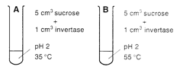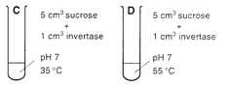

1. (i) In which of the test tubes above would you expect glucose to be detected first?

_____________________**C**________________________________________________________

(1 mark)

(ii) Explain why you chose this test tube.

___________**Invertase works best in neutral conditions/ pH of C is neutral/ 7 (1)**

**Temp is 35oC which is close to body temp/ optimum temp for enzymes (1)** ________________

(2 marks)

1. Explain why the enzyme amylase would not have been effective in carrying out this reaction.

_____**Enzymes are specific to one chemical reaction (1) sucrose is not the correct substrate for the enzyme amylase/ amylase will not break sucrose down into glucose and fructose (1)**

(1 mark)

1. List two variables that would be controlled during this experiment.

**concentration of enzyme/ substrate**

**volume of enzyme/ substrate**

**length of time (Any suitable)**(2 marks)

**End of Section 2 – Turn over for Section 3**

**Section 3: Extended answer (10 marks)**

This section has one question. Write your answers in the spaces provided.

**Question 15**

For the cells of a body to function normally, they must remain in a stable environment. Describe the structure of the cell membrane and explain how it allows the exchange of ions to occur.

|  |  |
| --- | --- |
| **Description** | **Mark** |
| **Any 8 of the following for CELL MEMBRANE:** |  |
| * **Fluid mosaic model**   + **Composed of phospholipid molecules**   + **Arranged in a bilayer/two layers**   + **Hydrophilic heads**   + **Hydrophobic tails**   + **Protein and/or cholesterol molecules embedded in bilayer**   + **Receptor proteins**   + **Channel proteins**   + **Carrier proteins**   + **Cell-identity markers**   **Note: a fully annotated diagram is acceptable** | **1-6** |
| **State the three types of TRANSPORT and how each occurs in relation to cell membrane:** |  |
| * + **Diffusion/Facilitated diffusion**   + **Molecules move between phospholipids OR move through channel protein**   + **Carrier-mediated**   + **Carrier protein in cell membrane binds to and transports molecules**   + **Vesicular** * **Movement of molecules in membrane bound vesicles** | **1-4** |
| **Total** | **10** |

**End of Test**